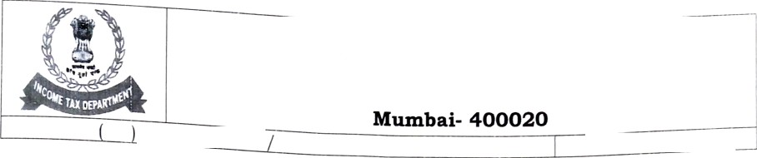
OfF _{Ge}
f the Cp
; S s ion _{e} r of Ineo
e
DRJ-
Room. pp, TAT }IBench, Mumbai
«,
F. No. CIT
DR -ITAT H Benc h
2022-23
s•' rioor, oie cno BuiIdng.
Date: 28.01.2k22

The Ho n'b1e Mem bers, ITAT ’H’ Bench
Mu mbai.

Sir,

ub: Request for adjouzozoent izz tbe case of:

Appeal fa. 5648/3g/ 11, 5649/it/ 11, 5650/gI/ 11 gs 565 /1M/11
Date of beazlzsg: 31/01/2022

Please refer to the above.

- The above referred appeal/ appeals is/ are reed on 31/ 0 I/ 2022 before this Hon Plc

Bench for hearing.
- This is inform to that the undersigned was sick and hospitalized and has just been discharged today. As such it is requested that your kind honour, please adjourn the hearing of the ab ove-mention ed case to any future date as deemed fit.
- The in convenie nce caused is regretted. The undersigned shall be highly obliged for x’our kind favour.
Yours sincerel› ,

lC•irish Dave}
Senior Standing Council,

ITAT-H-Bench , Mumbai.

