BEFORE HON’BLE INCOME TAX APPELLATE TRIBUNAL, “I” BENCH,

MUMBAI

ITA No. 3130/M/2006(Dept); 3135/M/2006
(Assessee)

C.O. No 324/M/2006 Assessment Year 2002-03

Written Note of Department dealing with Issues in appeal
Essentially, following issues are involved in these appeals & Cross- objections:
Taxability of Payment of USD 20, 50,000/- received by way of license fee in lieu of Transmission And Media Rights granted by Global Cricket Corporation, a company of Singapore (GCC, in short) to Set Satellite Singapore (PTE.) Ltd, another company of Singapore (Set, in short) towards grant of license for transmission of events of International Council of Cricket (ICC, in short) in India as royalty;
- Availability of Treaty benefit in respect of the aforesaid sum under Article 24 of India-Singapore Double Taxation Avoidance Agreement (the DTAA, in short);
- Taxability of sums earned under Sponsorship Agreements from LG Electronics Inc, Korea, LG AD Inc, Korea, LG Electronics India Pvt Ltd (LG, Group in short)& Hero Honda Motors Ltd, India (Hero Honda, in short); and
- Availability of Treaty benefit in respect of the aforesaid sum under Article 24 of the DTAA, in short.
It may be pertinent to mention that learned Commissioner of Income-tax, Appeals (CITA, in short) has refrained from giving any finding on the issue of royalty for reasons given in his order and the same is not repeated here for the sake of brevity.
Before one begins to deal with the issues, it would be appropriate to list various agreements entered into among the parties and these are as follows:-

  - Master Rights Agreement dated 20.07.2000 among ICC Development (International) Ltd, British Virgin Islands company (IDI, in short), The World Sport Group Ltd, British Virgin Island (WSG, in short) & The News Corp Ltd, Australia (News Corp, in short);
  - Novation Dated 02.07.2001 supplementing the agreement of dated 20.07.2000 with replacement of WSG by GCC as counterparty;
  - Agreement dated 25.01.2002 among GCC, World Sport Nimbus Pte. Ltd (WNS, inshort) & Set;
  - Novation dated 26.03.2002 entered into by & between IDI, GCC, WSN & Set;
  - Agreement dated 28.06.2002 with LG Group, GCC & WSN; &

  - Agreement dated 08.07.2002 with Hero Honda.

For and on behalf of the department an elaborate reading of various agreements and their relationship and nexus with each other was made so as to enable Hon’ble Bench to determine the true nature of these agreements.
Inter-relationship of various agreements as detailed above-
It must be borne in one’s mind that these agreements require to be read together in conjunctive way and not disjunctively for the simple reason that sponsorship Agreements would not be entered upon between the Singapore Company, GCC by two Indian companies for sponsorship rights in order to promote their business in India unless the Agreements by and between CCC, IDI & Set for transmission and Media rights had any nexus among the entire set of activities and the agreements serve the commercial interests of the two Indian Companies. True relationship among various agreements may not be possible unless one reads and finds connection among these agreements. In order to understand this issue kind attention may be drawn to stipulations in the Master Rights Agreement, agreement dated 25.01.2002 and novated agreement dated 26.03.2002. The agreement dated 25.01.2002 substituted previous counterparty in the agreement dated 20.07.2000 from WSG Ltd, a BVI company to GCC, Singapore company but certain additional Para were added by way of novation dated 26.03.2002 and more so with the inclusion of IDI whp was not a party in the previous agreement of dated 25.01.2002
However, an attempt has been made by and on behalf of the appellant- assessee that the transmission rights are for the purpose of providing ‘Live Feed’ which does not result in any ‘work’ and therefore royalty does not arise as there would be no copyright in the ‘Live feed’. It has been explained in the course of submission for and on behalf of the Revenue that feed is not ‘Live’ feed but ‘modified’ one and Para (4) to Para (11) enumerates various rights which are to be read with Para (15) to Para
(20) under the head “Deliverables”. A bare reading of these Paras would reveal that the feed is a ‘modified ‘one which would cater the needs of viewers in India which shall be produced by a producer appointed for the purpose. The producer shall provide it to GCC who has granted rights for transmission to Set. In effect, however, there is no transfer of the ‘modified’ feed to GCC as the television transmission would not wait for this stage to come and as soon as the feed is produced as per the agreement between the producer and GCC, the same would be passed on to Set for transmission across the licensed territory as defined in the agreement of which India forms part. The decision dated 26.09.2008 of Hon’ble High Court of Delhi in the case of ESPN Star Sports versus Global Broadcast News Ltd clearly holds that copyright exists in the ‘modified’ feed.
In order to understand the entire set of activities in its right perspective, one may begin with the last activity of flow of funds among various entities as depicted in following chart:-

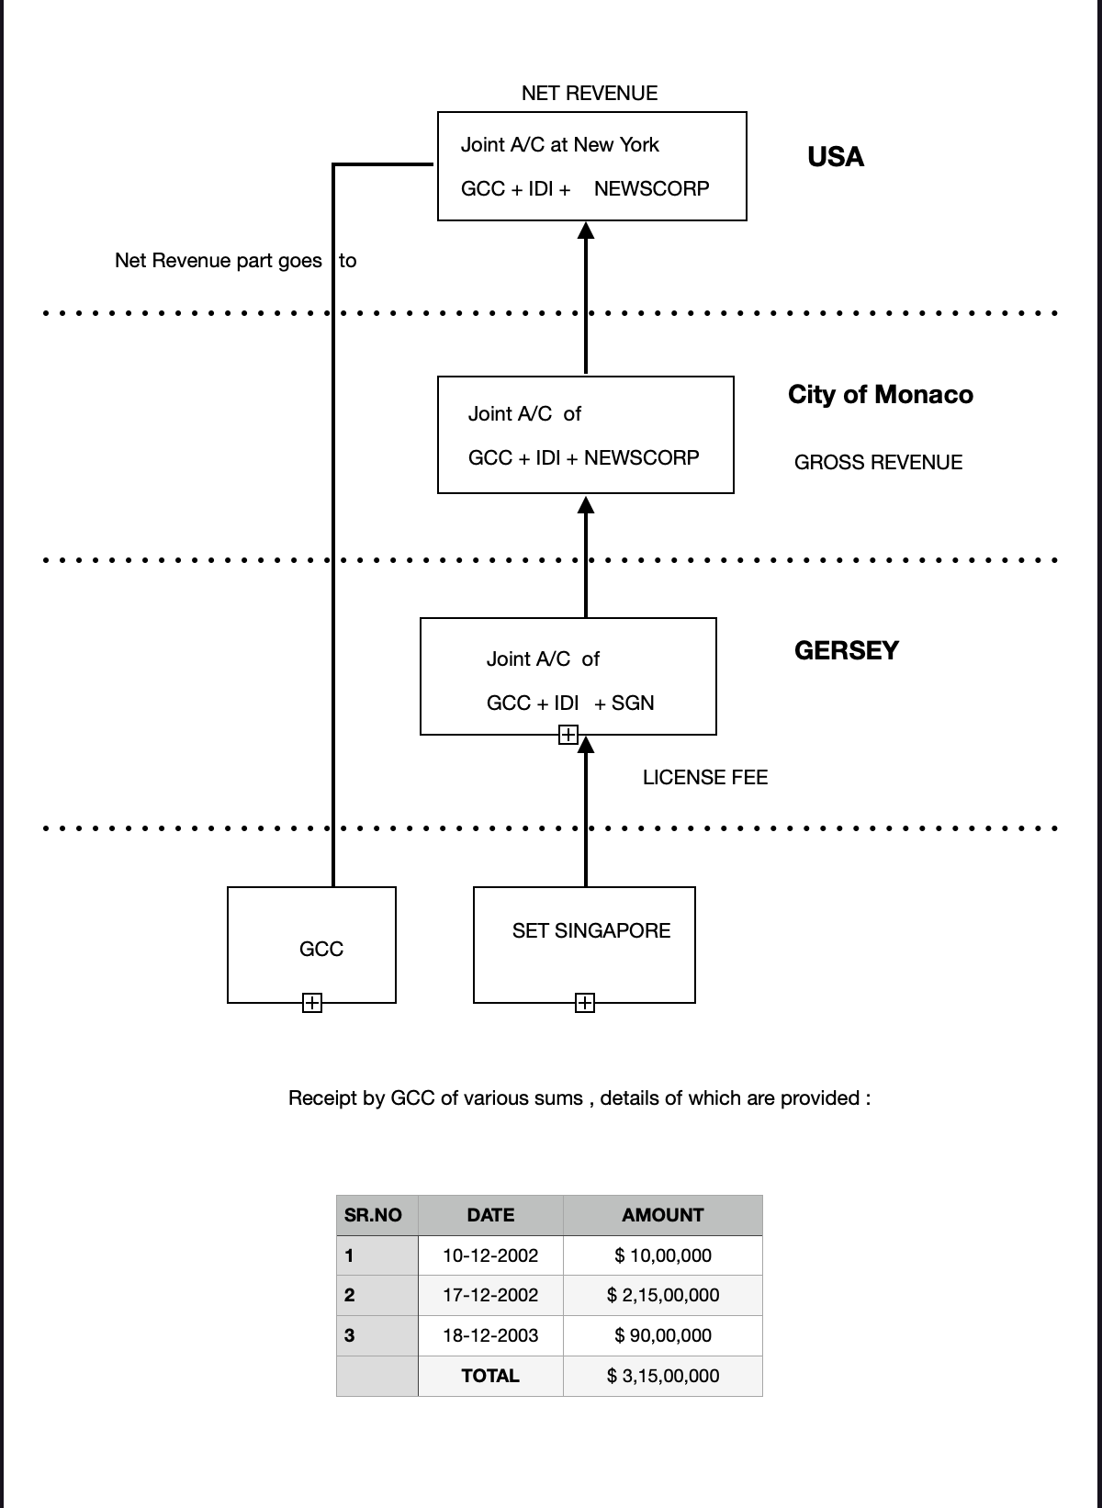

It may be pertinent to mention here that money did not reach GCC, A Singapore Company paid, as claimed, by another Singapore company. Set but by a circuitous route as shown in the chart above. If it was a simple case of payment of license fee between two Singapore companies, there could be no case of involvement of India domestic law and why a certificate for no or low deduction of tax was required in the context of agreement of dated 25.01.2002 and if at all, then it could be only for payment by LG and Hero Honda, two Indian companies.
Now, let us deal with the issues raised in the course of hearing of the appeals.

Proceedings for deduction of tax at source:

It is argued that the issues stand covered by decisions in the context of proceedings in this case itself for deduction of tax at source which travelled up to the stage of Hon’ble High Court of Bombay to hold that there was no roayalty in the ‘Live feed’ and particularly the transaction being between two companies which are non-residents and no activity carried out in India with transmission of ‘Live feed’ being from outside India.
Now, the proceedings were taken up by the Assessing Officer (In short, the AO) with the show cause notice with proposition that GCC was in default for the purpose of Section 201 read with Section 195 of the Income-tax Act, 1961 (In short, the ‘Act’). In the course of the proceedings GCC filed copy of agreement of 25.01.2002 holding back other agreements which were complimentary and supplementary to this agreement. The AO was put in apposition where he could decide the issue by analyzing only this agreement and not all the agreements the details of which are given above.
It may be appreciated that these proceedings are summary in nature and decision threin depends on the basis of the documents led by an applicant. It is for this reason that Hon’ble High Court of Bombay held in two judgments in the cases of CIT v Tata Engineering and Locomotive Co. Ltd reported in (2000) 245 ITR 823 (Bom.) and CIT v Elbee Services P. Ltd reported in (2001) 247 ITR 103 (Bom.) that:

“It is well settled that the orders passed under section 195(2) of the Income-Tax Act are not conclusive. They do not pre-empt the Department from passing appropriate orders of assessment. We have already taken a view in Income-Tax Appeal No. 217 of 2000 (CIT v. Tata Engineering and Locomotive Co. Ltd., [2000] 245 ITR 823 (Bom), in which this court has laid down that the ﬁndings given under section 195(2) of the Income-Tax
Act will not preclude the Department from taking a contrary view in the assessment proceedings”.
Suffice to say that the issue is settled by jurisdictional High Court and any number of arguments should not be considered to unsettle the matter. It is a fact that GCC held back a number of agreements which could never be considered by the AO and the same were not even produced before the authorities below. The full set of complementary and supplementary agreements were obtained at the stage of Hon’ble Bench by filing application for admission of additional evidence by and on behalf of the Department.
It is therefore urged that the findings given only in the course of assessment proceedings be considered for the purpose of deciding the issue as on the facts and in the circumstances of the case findings given in the course of proceedings for deduction of tax at source would not have any persuasive value.

Whether Income can be said to arise in India-

This issue was not decided by learned CIT (Appeals) in the appeal for the assessment year 2002-03 for the reason that he was convinced by the argument that provisions of Para (7) of Article 12 of the India-Singapore Tax Treaty (Treaty, in short) is applicable. Para (7) as the phraseology exists in the Treaty stipulates as under:-
  - Payer of royalties is a resident of a contracting State;

  - It pays royalties;

  - Irrespective of residence of the payer, if it has a PE somewhere;

  - Liability to pay arose in connection with that PE;

  - The liability is borne by that PE, then royalties would be deemed to arise in the state where PE is situated.
Paragraph (1) of the treaty lays down the principle of exclusive taxation of royalties in the state of the Owner’s residence that is the Payee’s state.
Paragraph 2) of the Treaty gives a secondary right to the state of payer, that is the state of source from where royalty is paid but in a limited way.
Paragraph (7) of the treaty excludes the concept of excusive taxation by resident state and deems the royalty to arise in the state of PE provided the liability pf the payer arose in connection with the PE and it is the PE which bear the liability to pay. This is a deeming provision and must be construed strictly. In the course of hearing of the appeals, a comparison in the form of a chart was submitted in order to emphasize that the language used in the two articles are different.
The case of the Department is that Paragraph (7) of the treaty would not be relevant as the royalties arose in India because of the intricate web of the Agreements and coverage of viewership in the Indian territory (may be forming part of the viewership) where Set, Singapore has a PE in India and which telecast matches in India and reference to Indian territory is provided in the agreements. Further, all the agreements including the two sponsorship agreements with LG India and Hero Honda India should be read together conjunctively and not in isolation of or to the exclusion of each other in order to appreciate ‘real’ effect of the agreements. It is well settled in law that various agreements forming part of the same activity nust be read together to construe and determine the effect of the agreements. All the agreements were read elaborately clause-by–clause and Para-by-Para.
The finding given by learned CIT(Appeals) in this regard requires to be sustained and may kindly be sustained.

How does the income arise in India?

Indeed, it is argued that the ‘feed’ is sent to Singapore and the transmission of the same is also from Singapore. The matches are played outside India and therefore there is no occasion for income to arise in India. The payment is also made outside India by Set, Singapore to GCC, Singapore.

But, this assertion is not wholly correct. As per the production agreement, ‘feed’ is created at the place where match is played and access to the production team and other teams assisting it, is procured by GCC from the organizer of the matches who happen to be state associations who are owners of the ground.. It is a fact that matches were played in India also. At least, one match was played in India of the matches included in the Schedule of the Agreement. The appellant-assessee has in the course of hearing has provided details in this regard but from the Schedule itself it is evident that at least one match aas played in India. In order to create ‘f’eed', the production team and other assisting teams with their personnel and equipment were present on the ground in India to create the same. This fact establishes ‘nexus’ with India. Then there are clauses which provide the territory which would be covered by transmission of the ‘Feed’, including India. The agreement of dated 25.01.2002 makes provision to define, Pay-per-view, terrestrial rights, terrestrial restrictions, telephony rights, video rights and theatrical rights to define how these rights can be exercised. The rights enumerated in Para (4) to (25) would certainly have nexus with the areas covered in the definition of ‘Licensed territory’ which includes India. This pre-supposes that the Licensor, GCC has got license to transmit the ‘feed’ in these territories. How and when, would be the issues open to speculate? A reading of Para (27) with Schedule 1 defines the consideration for license fee of which details are given in the Schedule which is spread over for the periods from the year 2002 to 2007 with other stipulations like, authorized number of exhibitions, minimum commitment and rights. This fact would again establish ‘nexus’ with the areas included in the definition of licensed territory. As the information available, it may be seen that that the payment of license fee included for organizing ICC Championship Trophy held in India in the year 2006 and as per schedule 2 to the agreement, it is apportioned at 11% of the total consideration.

